TITLE PAGE
Title of Your Paper: Capitalize First Letter of Each Word

First Author¹, Second Author², Third Author³
¹First affiliation, City, (Country); ²Second affiliation, City, (Country); ³Third affiliation, City,
Country

Corresponding author: Author Name
Affiliation, Address, City and Postcode, Country
Tel: + , Fax: +, E-mail:

ORCID
First Author
Second Author
Third Author

Authors’ Contributions
Conceptualization: MHC. Data curation: JH. Formal analysis: YIA. Funding acquisition: MHC.
Methodology: MHC, JH, YIA. Project administration: YIA. Visualization: MHC, JH, YIA. Writing – original draft: JH, YIA. Writing – review & editing: MHC, JH, YIA.

Conflict of Interest
If there are any conflicts of interest, authors should disclose them in the manuscript. If there are no any conflicts of interest, authors should describe following sentence. “No potential conflict of interest relevant to this article was reported”.

Running Title: Less Than 50 Characters including letters and spaces
Abstract
Abstracts for review articles provide within one paragraph the purpose, methods, important results, and conclusions in an unstructured format. The words should be less than 250.

Keywords: A; B; C

KEY MESSAGES
A list of 2 or 3 key messages is required. This provides a quick structured synopsis of the findings of your manuscript, following important findings and its meaning. Limit this section to 50-100 words or less.
⦁
⦁
⦁

MAIN TEXT
The main text consists of the Introduction, Main body, and Conclusions sections. Acknowledgments sections may be included following Conclusions.

INTRODUCTION
The manuscript should be provided in MS Word file (doc, docx), double spaced on 212 mm×297 mm (A4 size) with 2 cm on each side and 3 cm for the upper and lower ends. The length of the manuscript should not exceed 5,000 words except for the cover, tables, figures, and references.

Abbreviation
The use of acronyms and abbreviations is discouraged and should be kept to a minimum. When used, they are to be defined where first used, followed by the acronym or abbreviation in parentheses.

Citation of Reference
References should be numbered consecutively in the order in which they are first mentioned in the text. Each reference should be cited as [1], [1,4], or [1-3]. When quoting from other sources, give a reference number in bracket after the author’s name or at the end of the quotation. Examples are as follows:
1) It is said that hypertension can be brought [1] and the way to injure brain [2] is...
2) Smith et al. [3] reported---
3) Park and Kim [4] reported---
4) This is … presented [5].

MAIN BODY
Primary section headings should be left justified, with the all letter capitalized, starting with the Introduction. Subsection headings should be structured as follows:

PRIMARY SECTION HEADING
Secondary Subsection Heading
Tertiary subsection heading
Quaternary subsection heading:

Tables and figures should be indicated in main text as follows: (Table 1), (Tables 1, 2), (Tables 1-3), (Figure 1A, B), (Figure 1A-C), (Figures 1, 2), (Figures 1-3), (Figures 1A, 3B), (Table 1, Figure 2).

CONCLUSIONS

ACKNOWLEDGMENTS
Persons or institutes who contributed to the papers but not enough to be coauthors may be introduced. Financial support, including foundations, institutions, pharmaceutical and device manufacturers, private companies, intramural departmental sources, or any other support should be described.

REFERENCES
A. Regular Journal
Author Last Name First Initial Middle Initial. Title of manuscript. Name of journal Published year; Volume: Start-End page.
Ex) Lee DH, Kim EY, Seo GJ, Suh HJ, Huh JW, Hong SB, et al. Global and regional ventilation during high flow nasal cannula in patients with hypoxia. Acute Crit Care 2018;33:7-15.
Ex) Bernard GR, Artigas A, Brigham KL, Carlet J, Falke K, Hudson L, et al. The American-European Consensus Conference on ARDS: definitions, mechanisms, relevant outcomes, and clinical trial coordination. Am J Respir Crit Care Med 1994;149:818-24.

B. Standard Book with Authors
Author. Book name. Edition. Place of publication: Publisher; Published year. Mark edition if it is beyond the 2nd edition.
Ex) Nuwer MR. Evoked potential monitoring in the operating room. 2nd ed. New York: Raven Press; 1986.

C. Standard Chapter in a Book
Authors of chapter. Title of chapter. In: Editors of book, editor(s). Title of book. Edition. Place of publication: Publisher; Published year. p. Start-End page.

Ex) Blitt C. Monitoring the anesthseized patient. In: Barash PG, Cullen BF, Stoelting RK, editors. Clinical anesthesia. 3rd ed. Philadelphia: Lippincott-Raven; 1997. p. 563-85.

D. Electronic Format
• Electronic publication before print
Ex) Lee OJ, Cho YH, Hwang J, Yoon I, Kim YH, Cho J. Long-term extracorporeal membrane oxygenation after severe blunt traumatic lung injury in a child. Acute Crit Care 2017 Feb 10 [Epub]. https://doi.org/10.4266/acc.2016.00472.
• Website
Ex) Sage Terapeutics. A study with SAGE-547 for superrefractory status epilepticus [Internet]. Bethesda (MD): U.S. National Library of Medicine; 2000 [cited 2016 Nov 12]. Available from: https://clinicaltrials.gov/ct2/show/NCT02477618?term=NCT02477618&rank=1.

Other types of references not described below should follow The NLM Style Guide for Authors, Editors, and Publishers (https://www.ncbi.nlm.nih.gov/books/NBK7256/).

(Sample Table)
Table 1. Demographics and baseline variables before performance of the Valsalva maneuver
Variable | Visibility grade A (n=97) | Visibility grade B (n=53) | Visibility grade C (n=50) | P-value
Sex (male:female) | 45:52 | 22:31 | 17:43 | 0.352
Age (yr) | 52±18 | 45±15 | 50±17 | 0.081
BMI (kg/m²) | 22.80±3.61 | 24.12±3.13* | 24.14±3.39* | 0.025
EJV CSA (cm²) | 0.19±0.17 | 0.18±0.16 | 0.14±0.17 | 0.159
EJV depth (mm) | 2.31±1.04 | 2.98±1.12* | 3.30±1.24* | <0.001
MBP (mmHg) | 70.08±6.87 | 71.19±7.05 | 69.62±8.05 | 0.517
HR (beats/min) | 72.88±11.15 | 73.84±11.05 | 73.09±11.33 | 0.896
Values are presented as mean±standard deviation.
Visibility grade A: good appearance and good palpation; Visibility grade B: poor appearance and good palpation; Visibility grade C: poor appearance and poor palpation; BMI: body mass index; EJV: external jugular vein; CSA: cross-sectional area of external jugular vein; Depth: depth from the skin to the external jugular vein superficial surface; MBP: mean blood pressure; HR: heart rate.
*P<0.05 vs. visibility grade A.

(Table guide)
Each table should be typed or printed on a separate sheet of paper consecutively in the order of their first citation in the text. Supply a brief title on the top of the table. Title of the table start as “Table 1”. Only horizontal lines should be used within a table, to distinguish the column headings from the body of the table, and immediately above and below the table. Footnotes should be provided consecutively in order of the informations, statistics and abbreviations. Footnoted information should be referenced using superscript, small letters (ex; a, b) in alphabetical order.
(Sample figure)
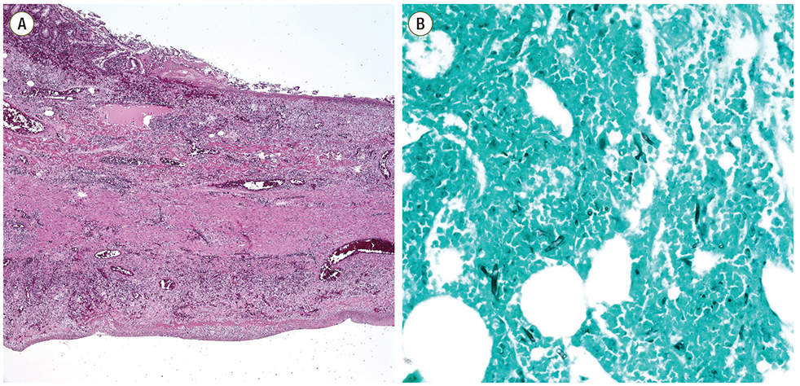
Figure 1. Microscopic findings of the resected small bowel. (A) Microscopic findings of the small bowel showed vasculitis and transmural infarction (H&E, ×40).

(Figure guide)
Images must be provided as TIFF files. JPEG is also acceptable when the original format is JPEG. Each figure must be good quality higher than 300 dpi resolution with good contrast and sharpness. The figures must be sized to 4 inches. If possible, submit the original file without any modification. Number figures as “Figure Arabic numeral” in order of citation (ex. Figure 1). If figure is divided into more than two, mark each figures with Arabic numeral and capital alphabet (Ex. Figure 1A, Figure 1B). An individual should not be recognizable in the photographs unless written consent of the subject has been obtained and is provided at the time of submission. Scales should be presented as a bar in the picture or as a magnification remark in the legend.
Except for especially complicated drawings that show large amounts of data, all figures are published at one page or one column width; when the figures are reduced to the size of a single column or of a single page width, the smallest parts of the figure must be legible.

